UK Television

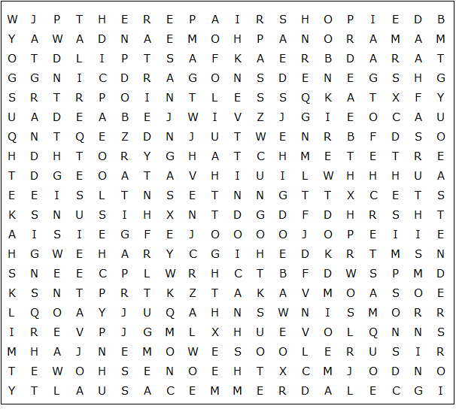

Coronation Street Match Of The Day The Repair Shop
The Apprentice Grand Designs Bargain Hunt Countryfile
The Simpsons Casualty Home And Away This Morning
Masterchef Mastermind Eastenders The One Show
Loose Women Dragons' Den The X Factor Gogglebox
Pointless Newsnight Emmerdale Breakfast Milkshake!
Panorama The Chase

UK Television – Solution

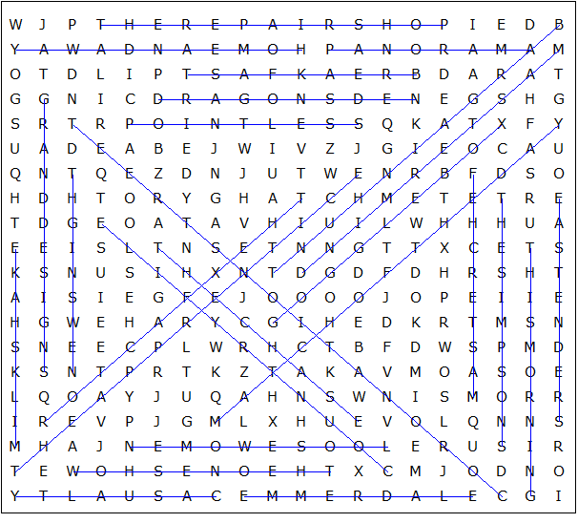

This worksheet was made up using TOOLBOX by Discovery Educational Software.

